# Go from 0 - 1000 followers using a simple secret

### [Build your brand the right way]



[Smoul](https://notaprodigy.beehiiv.com/authors/b714c51d-eaa0-4a05-9f33-0c014aaa95e1)  
July 29, 2023

**Read time: 3 min**

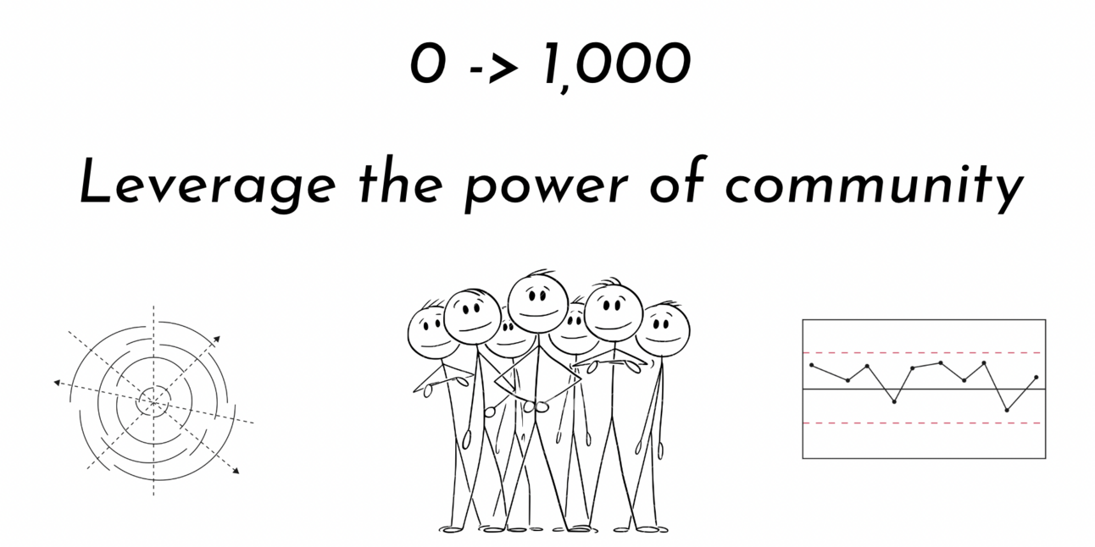

Starting as a creator the most frequently asked question would be

#### “But, how do I grow my audience?”

You’re right. It is daunting and truly overwhelming. You look up articles online and read suggestions of people with **20.3K followers** only to realise they all say the same thing

* Share high quality content
* Stay consistent and tweet 2X times a day
* Engage with people
* Find your voice

Now this is an advice that is useful, but not useful enough to get you up from scratch. You spend hours trying to build the perfect thread, create visuals and schedule your tweets but they end up having three digit impressions. Here is what you are not doing:

### Engaging mindfully

If I were to create a brand new twitter (I am just not used to calling it X) account tomorrow with 0 followers, I would spend 40% of my time formulating tweets and 60% of my time engaging with people in my niche.

That is the perfect start to get in the eye of people.

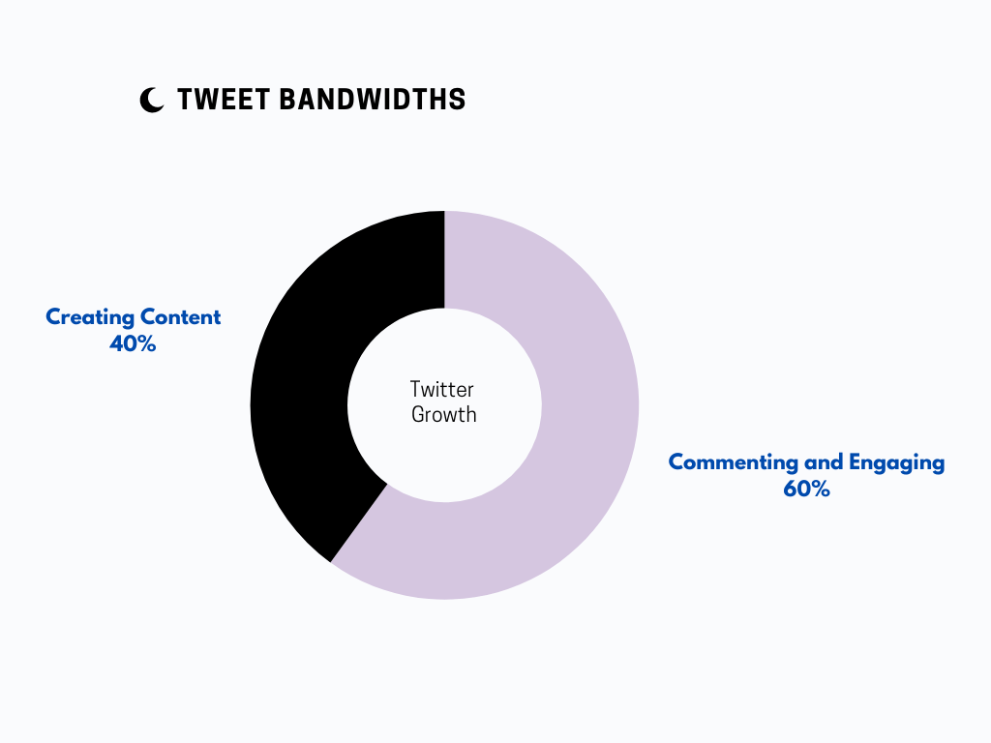

### Why does this work?

1. You are starting as a creator. Twitter has 400M+ users and you will be just one of them. How will you make sure that people hear you? It will be like finding a needle in haystack.  
     
   So instead of focusing on building a fresh audience, take leverage of people who already have an audience. Let people in that niche notice you and hear your thought.
2. It will help you build your impressions. While your own tweets can get low impressions in the start, your comments under people with high engagement can bring you that traction.
3. Treat these comments like mini tweets. Don’t go on taking them lightly otherwise it won’t work. Use your tweet ideas as comment ideas.

Now that we know comments are useful, how should you make use of them smartly.

Try not to comment things like

* WOW
* That’s great
* I agree

These comments will not get you anywhere because they neither add any value to the tweet of the other person nor they help you in portraying your voice and your point of view.

When we say use comments as mini tweets, you need to put your personality into them and make them more thought provoking. Here are 3 types of comments that you can make your use:

#### 1. Ask questions

When most people under the tweet would be adding mediocre statements, stand out by asking a question. It makes you seem curious and can help you get noticed by the creator.

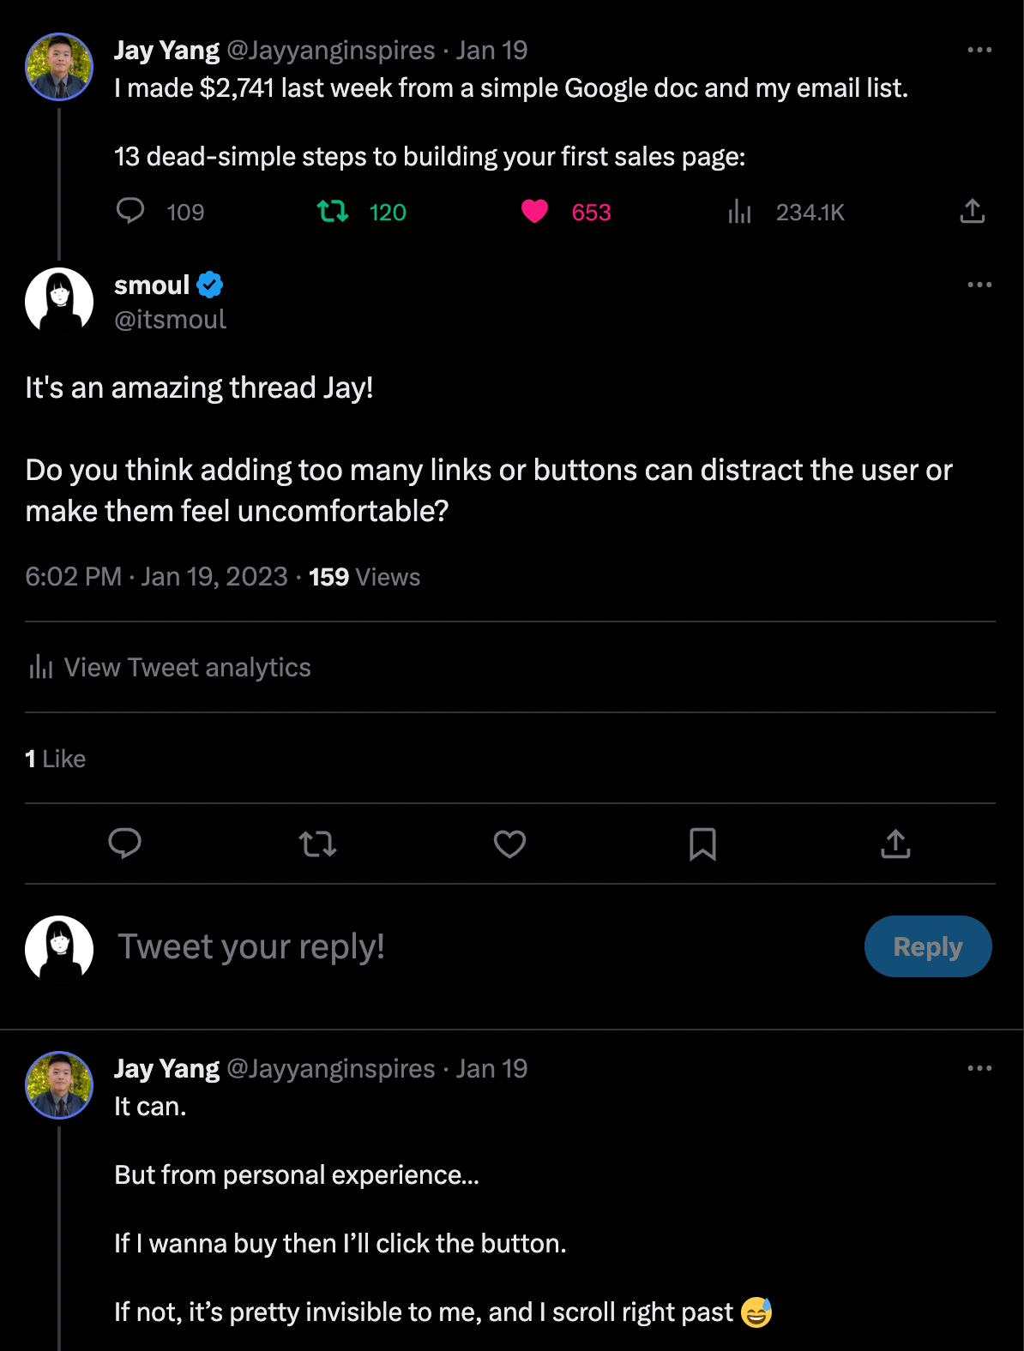

In the above tweet, I would have simple finished by writing the first sentence but I followed it up by a question. Now that helped me get 159 views [when as a beginner that seemed like a huge number] and also get into the eye of a bigger creator.

#### 2. Give your point of view

As a beginner creator how will you stand out? By sharing your own opinions. When your own tweets are not getting enough screen time, use them as comments and see what people have to say. You’d be surprised by how well that works.

You not only build a voice but also attract an audience that thinks the same way as you.

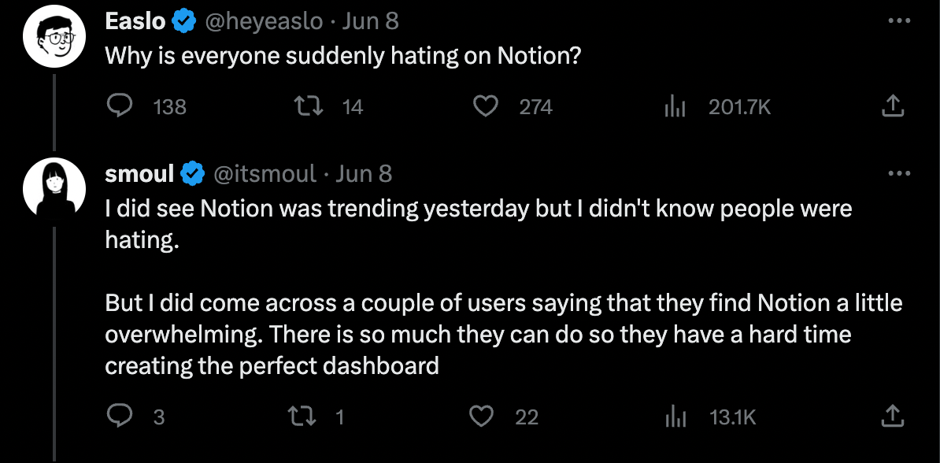

**13.1K** impressions only from a comment. You see the power I am talking about. This 1 comment brought me 23+ followers alone - a number that would have taken me 20+ days [by an average of 1 follower a day]

#### 3. Add value to the tweet

Now this is possible that you are not able to come up with a good question to ask or it is tough to state an opinion too. What to do next?

Take the core value from the tweet, put it in a list or just share with an added sentence.

For example if someone shared a tweet about “10 ways to become a better content writer” You can just comment things like

* which one the above technique is most used by you
* I personally loved ____ as it has helped me become a better writer
* I also find ___ to be amazing. It is something underrated but works for me

Learning how to engage with other users on the platform smartly can lead to new connections and new friendships. People will start understanding your point of view and learn your name as a prominent individual in the niche.

But, all this is possible only when you give up on the idea of ‘liking tweets’ as engagement. Twitter’s algorithm also favours people who frequently engage with people.

#### OFFER

Coming to this week’s offer. I have something more than just a discount. I have an entirely new product.  
  
Do you know Naval Ravikant, yes the entrepreneur that has inspired so many to start their own ventures. I spent the last 80+ hours reading his book and hearing his podcast “How to get rich” to note down the most used mental model.

Not only that, I have created a Notion template for the prominent mental models so that you can apply those learning in real life and learn from these mental models.  
  
As you all are close to my heart, here is a**30% off**on the purchase only for you. Use the code **GWNR30** and avail the benefit. Don’t forget to upvote and comment!

#### [*Grow With Naval Ravikant*](https://www.producthunt.com/posts/grow-with-naval-ravikant/maker-invite?code=QM3czN&utm_source=notaprodigy.beehiiv.com&utm_medium=referral&utm_campaign=go-from-0-1000-followers-using-a-simple-secret)

See you again in the coming week  
Smoul  
[The commenting ninja]